[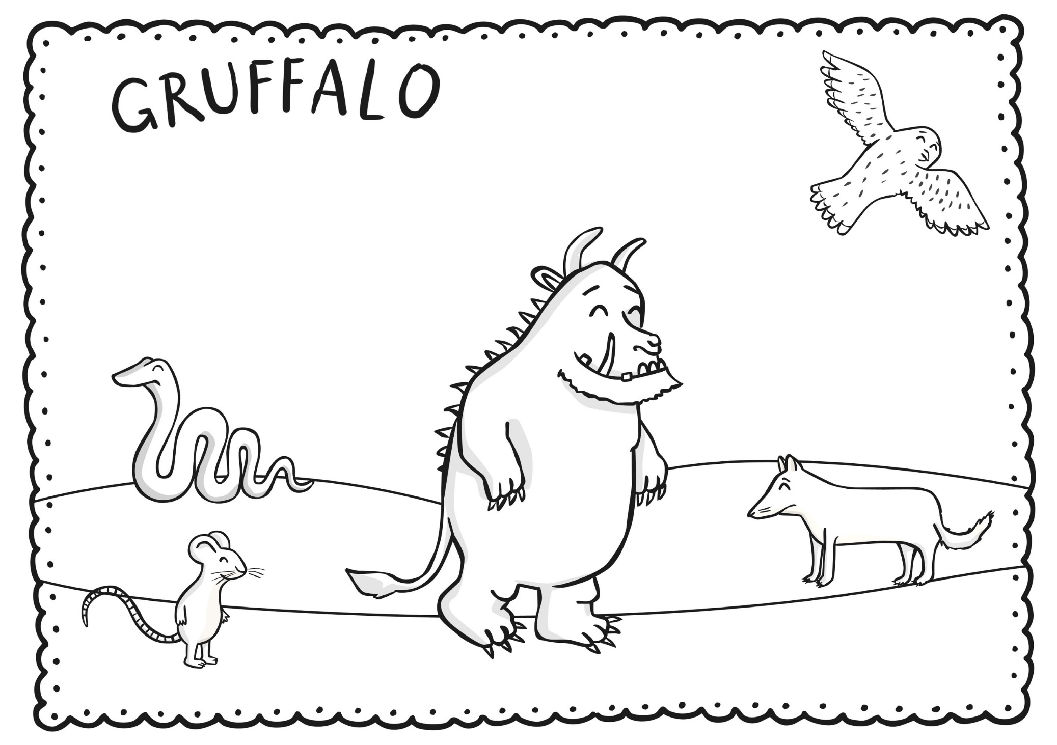](https://www.google.be/url?sa=i&rct=j&q=&esrc=s&source=images&cd=&cad=rja&uact=8&ved=2ahUKEwjJmqii2PPaAhVDyKQKHRQnDDoQjRx6BAgBEAU&url=https://nl.pinterest.com/pin/372602569143176270/&psig=AOvVaw2n4SUqF5p4JlGYgKoVrAKb&ust=1525785546741893)